2017 APPLICATION FORM  Helen McCloy/MWA Scholarship for Mystery Writing | Office use only:  App No  Received
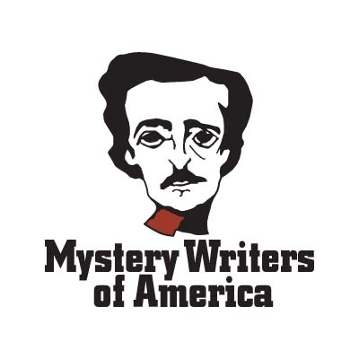
PLEASE KEY IN ALL INFORMATION and SEND TO: McCloy.MWA@gmail.com
Applicant’s Full Name
Home Address
City State Zip Code
Telephone E-Mail
Applicant’s date of birth (month/day/year)
Type of course/workshop/seminar to which scholarship would be applied:
College / University Level Writing Class Writing Workshop / Seminar
Title of Class / Workshop / Seminar
Dates of Class / Workshop / Seminar
Fee for Class / Workshop / Seminar $
Scholarship checks are made out jointly to scholarship winners AND their educational institutions. Please provide the following information for the person at your educational institution who should receive a copy of your award letter:
Contact Person Name and Title
Educational Institution Name
Mailing Address
City State Zip Code
Telephone Website
Checklist of items to email together as attachments in ONE email submission:
ONE completed application form (this form) for the 2017 scholarship being applied for.
ONE copy of the official, complete description of the writing class/workshop/program prepared by the institution offering it (copy from college catalog, workshop brochure, downloaded materials that show all information about the program). URL link or scanned doc is acceptable.
One copy of a short essay (300-500 words,) explaining applicant’s interest in mystery writing). One copy of a mystery writing sample to be judged: either a synopsis and the first 3 double-spaced chapters of a novel; or 3 double-spaced short stories; or 3 double-spaced nonfiction chapters or short essays; or 1 complete screenplay or play script.
Electronic Signature of Applicant Date
How did you hear about the McCloy Scholarship?

Submit all application materials to:
McCloy.MWA@gmail.com
Put “Submission” in subject
E-mail for inquiries: McCloy.MWA@gmail.com
Application deadline: February 28, 2017

